May 2019 Newsletter

Healthy Eating
We returned to John Lewis at the Watford INTU centre for a healthy eating workshop and talked about how healthy eating keeps us energised and well. We put our learning to the test, by making ourselves a delicious yet healthy baguette. Meanwhile, at the Jubilee Club, Amanda Hardy, one of our amazing volunteers, led a pizza making evening, where lots of fabulous toppings were sampled.

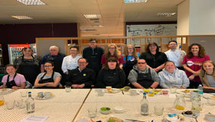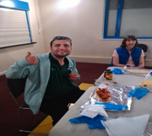

Daily Activities welcome two new sessional leaders
Angie has joined aerobics as our dance instructor, while Deborah is our new drama teacher. We are really excited to have them on board and we can’t wait to see what they have in store for us all.
If you are interested in joining in our activities, but not sure if you will like it, don’t forget, your first session is FREE.
Contact Francesca for more details. francesca@hertsmeremencap.org.uk/ 07938 722 619

Radlett Rotary Fun Run 6th May 10am – 2pm, Radlett Cricket Grounds
An incredible £4,000 was raised for the Radlett Rotary Club, of which Hertsmere Mencap will receive a contribution. A further £647 was raised on the day. Well done to everyone who joined in.

Dates for the diary

21st June 1030-2pm FREE FUNDAY - Borehamwood Football Club,
To celebrate Learning Disability week, we are hosting a fun filled sports day with medals for everyone, refreshments and lively activity in partnership with Borehamwood Football Club and Home Farm Trust. Contact Lucy Sitton for information. lucy@hertsmeremencap.org.uk/ 07770 746 655

23rd June - Volunteer Celebratory evening
To celebrate our dedicated volunteers, we are holding a get together to say thank you. Hertsmere Mencap could not survive without the support of its volunteers.

25th July – 21st August Noah’s Ark summer playscheme
Job opportunities are available for Play Assistants and volunteers for summer playschemes 2019. Contact Rochelle Gould for more information. Noahs-ark@live.co.uk/ 020 8906 2783 https://www.hertsmeremencap.org.uk/vacancies/

