HEALTHIER YOU – FREE SIX WEEK WORKSHOP
Starts on Wednesday 29th April, 10-12pm, @ 96 Shenley Road, Borehamwood

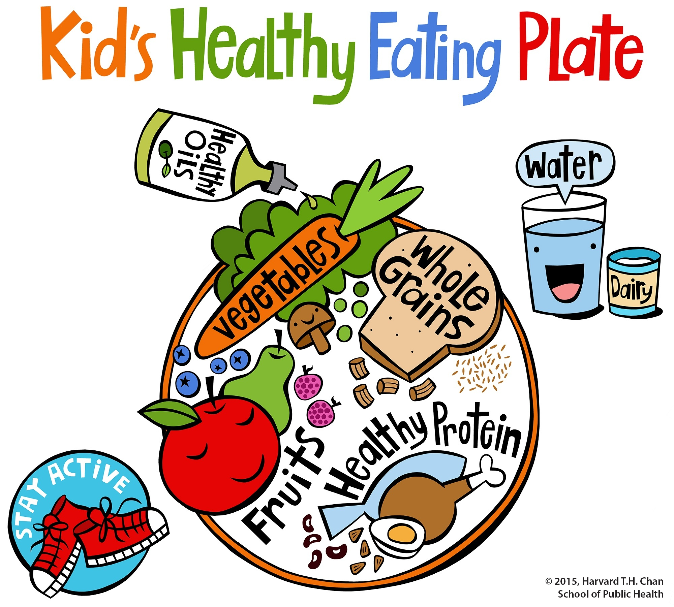

This class will help you to:

- Feel confident enough to plan healthy balanced meals with different ingredients and identify healthy foods in a supermarket.

- Understand why movement and exercise are important and how it keeps us healthy

- Learn about healthy snacking

- Know the importance of drinking water and knowing how much food you should eat each day

- Plan positive changes to your life to feel better, both physically and mentally.

For more information or to book your place on the course,
e: lucy@hertsmeremencap.org.uk, phone: 07770 746 655
www.hertsmeremencap.org.uk

